Automating Resize The Image Processing with AWS Lambda and S3
Introduction
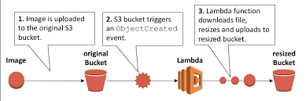
In the contemporary digital era, the automation of image processing tasks has emerged as a critical strategy for optimizing workflows and improving operational efficiency. Amazon Web Services (AWS) offers robust solutions for such automation through the integration of AWS Lambda, a server less computing service, and Amazon S3, a highly scalable cloud storage platform. Together, these services facilitate the automatic processing and resizing of images in response to file uploads. This article presents a comprehensive guide to the implementation of AWS Lambda functions that are triggered by S3 events, enabling real-time, automated image processing within a cloud-native architecture.

Getting Started with AWS Lambda

In this tutorial, the AWS Management Console is utilized to create an AWS Lambda function and configure it to be triggered by an event in Amazon Simple Storage Service (Amazon S3). Specifically, the Lambda function is automatically invoked each time a new object is uploaded to the designated S3 bucket, and it logs the object's type to Amazon Cloud Watch Logs. The integration of Lambda functions with S3 event triggers enables the automation of various file-processing operations. For instance, Lambda functions can be employed to generate image thumbnails upon the upload of image files or to convert documents into alternative file formats, thereby facilitating efficient and scalable data processing workflows.

Table Of Content
- Introduction
- Setup Check list for Mini Project

- Setup Check list for Mini Project

- HARDWARE
- 12th Gen Intel(R) Core(TM) i7-1255U 1.70 GHz
- Windows 11 Pro
- Memory: 16GB RAM / 512GB Storage
- SOFTWARE
- Work on AWS management Console.
- Automating Resize The Image Processing with AWS Lambda and S3.

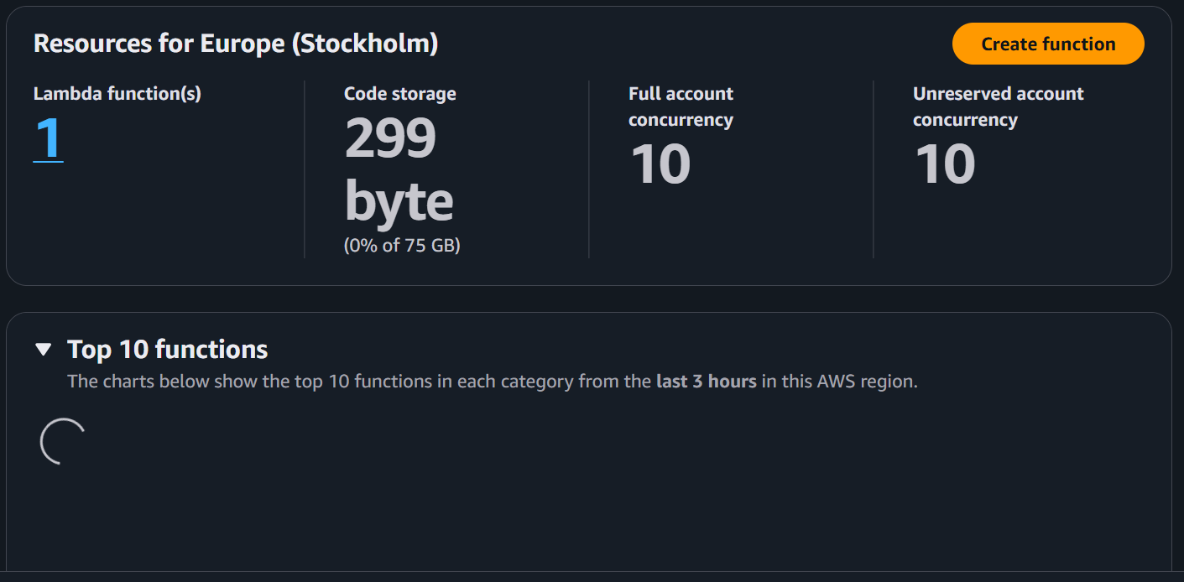
Step 1- create a lambda function.
Step 2- run time select node.js20x.
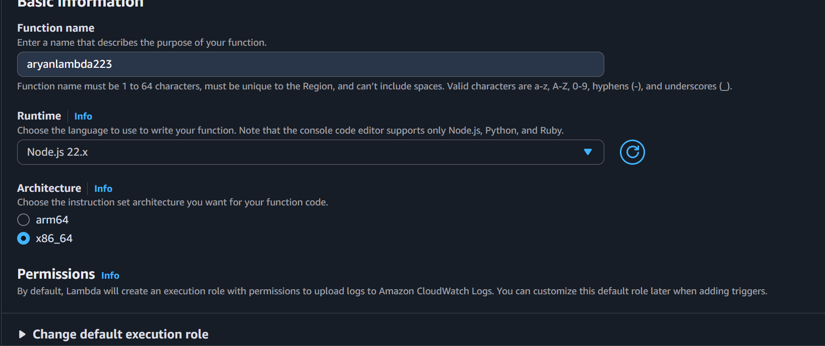
Step 3- Select an existing role.

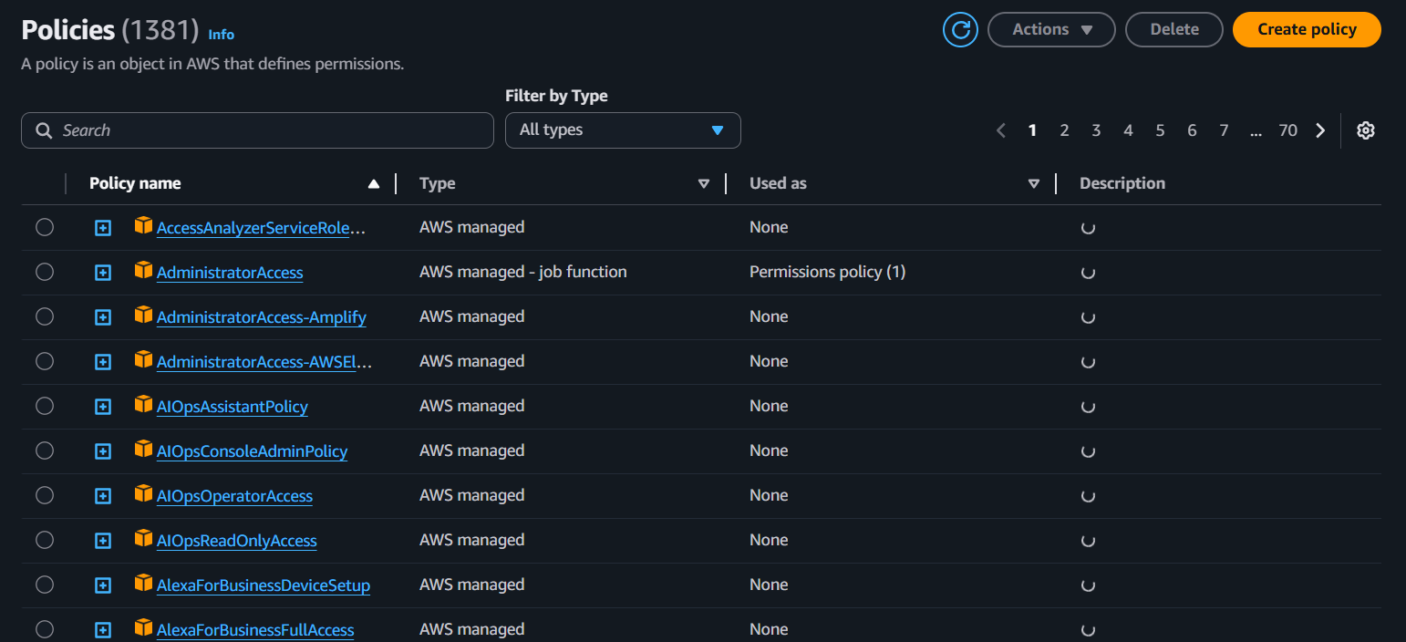
Step 4 - before going to select a role create an IAM role and policy.
Step 5- go to json add policy in JSON format.
- select next.
- This code in resources adds you are s3 bucket name.
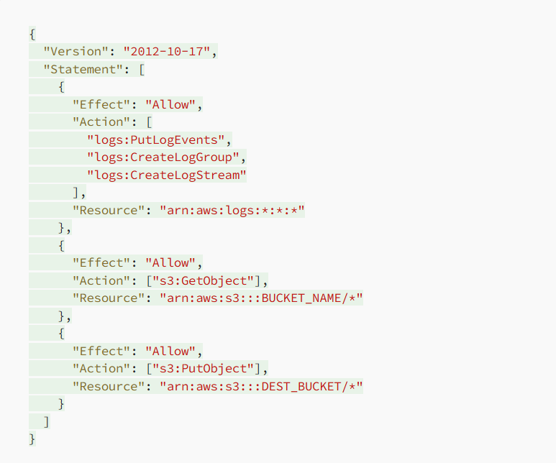

Step 6- Create a policy with a name.
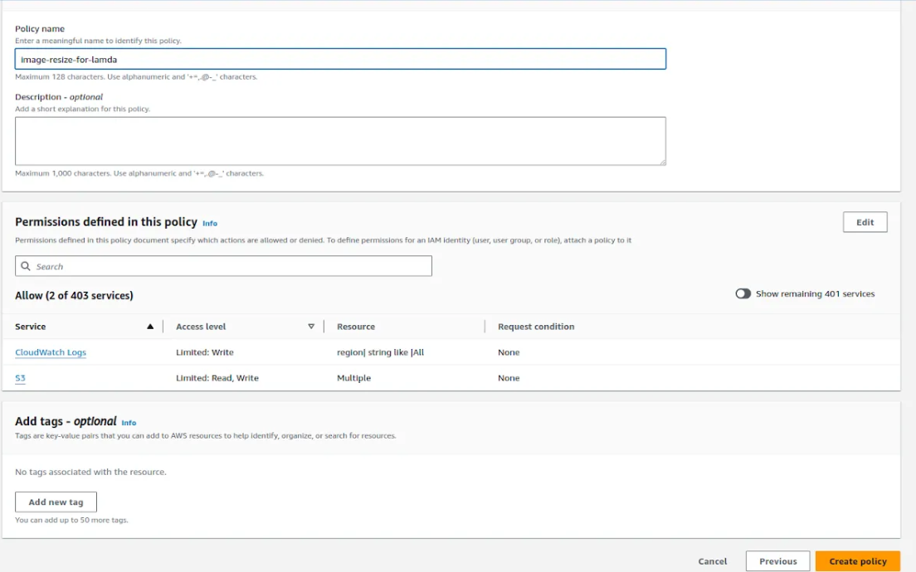
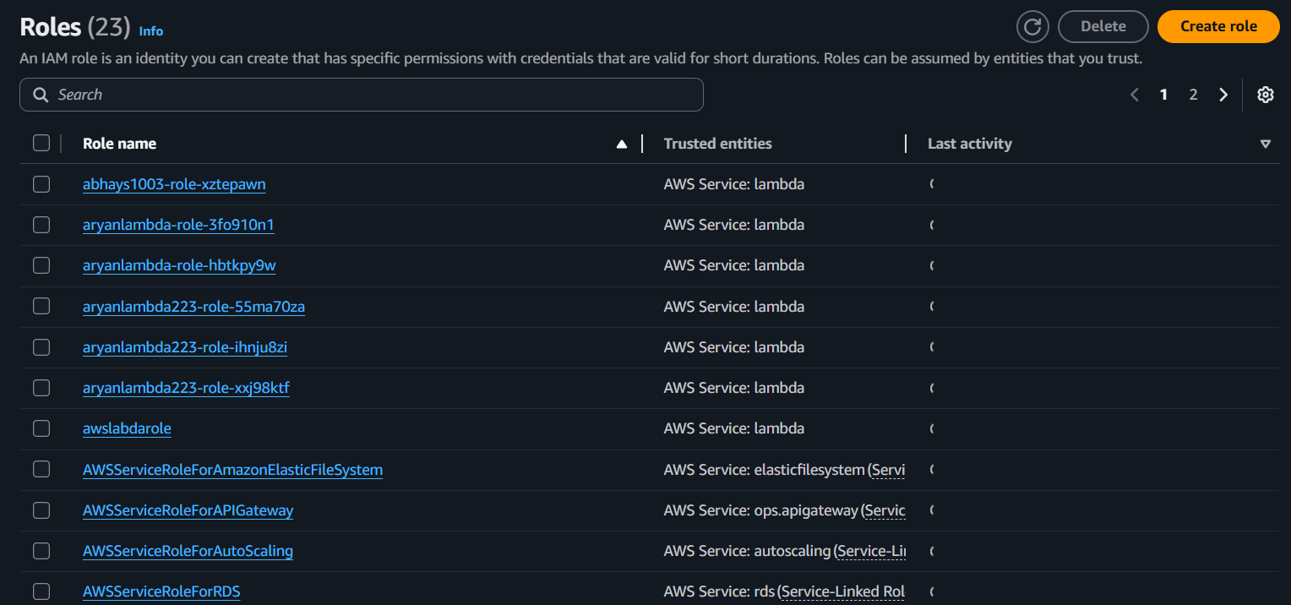
Step 7- Now create a role for this policy.
Step 8- Select AWS service.
Step 9- Use case Lambda.
Step 10- Select Next.
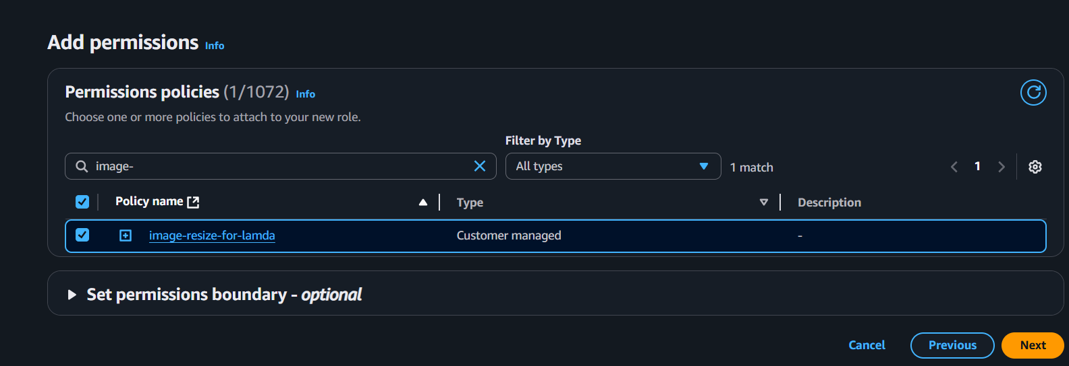
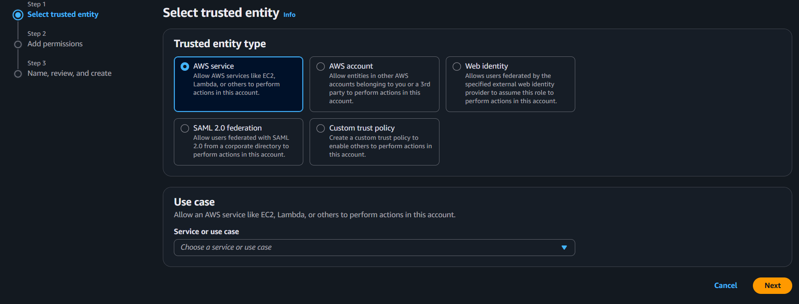
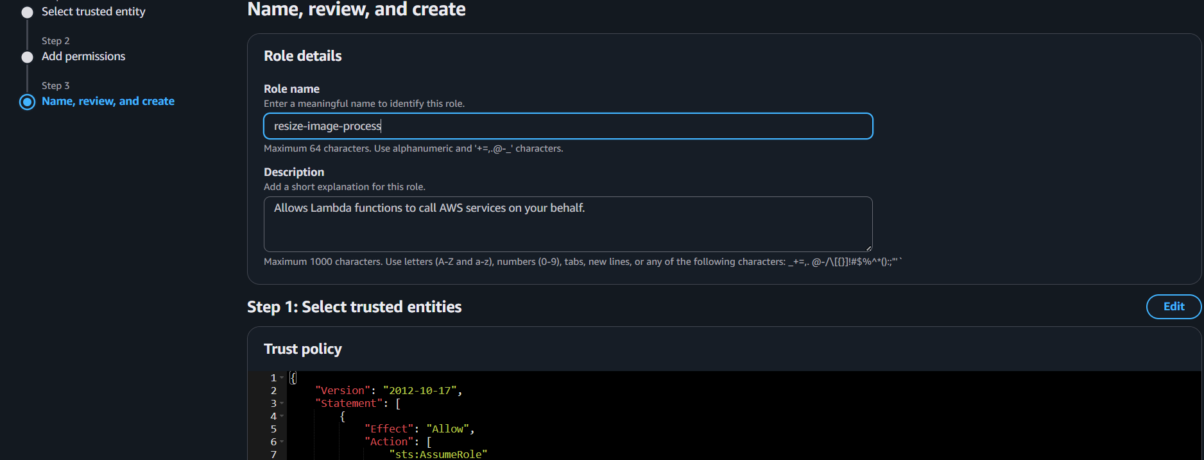
Step 11- Select role name.

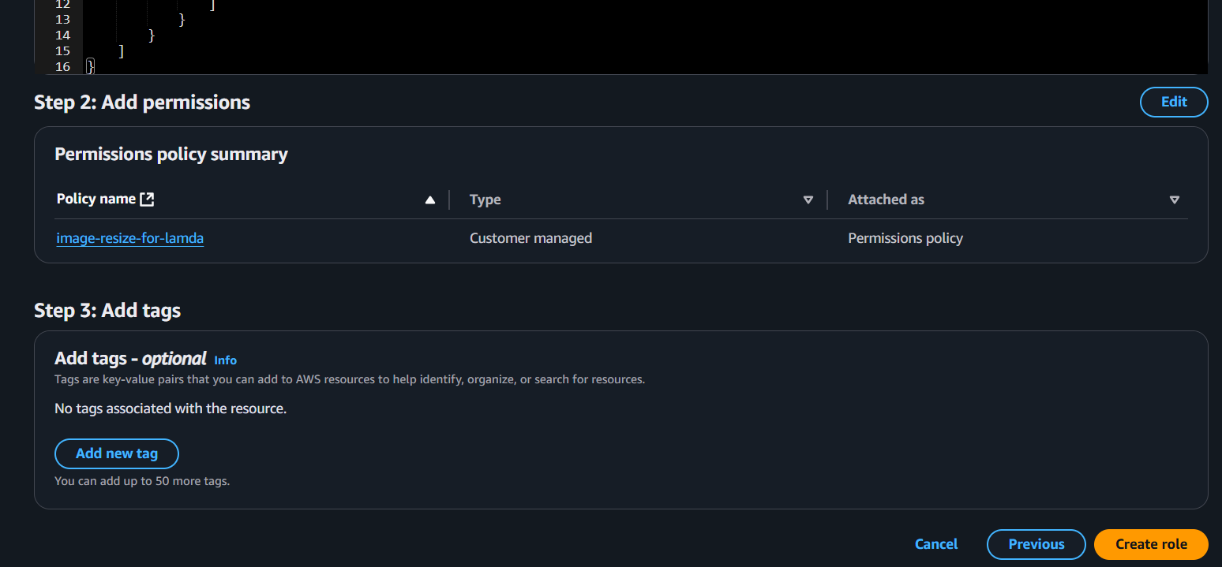
Step 12- After selecting create lambda function.
Step 13- Now you can see the function.
Step 14- Now add trigger.
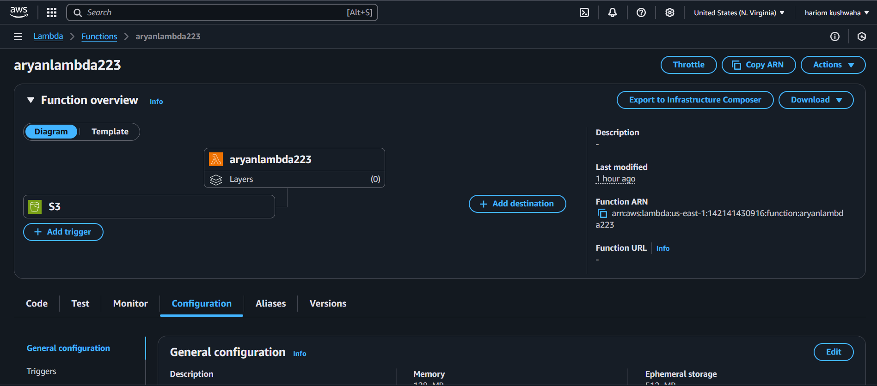
Step 15- Select s3 select the bucket the image is uploaded.

Step 16- Now create two s3 Bucket.
Step 17- Now upload the .jpg image to process lambda to s3.
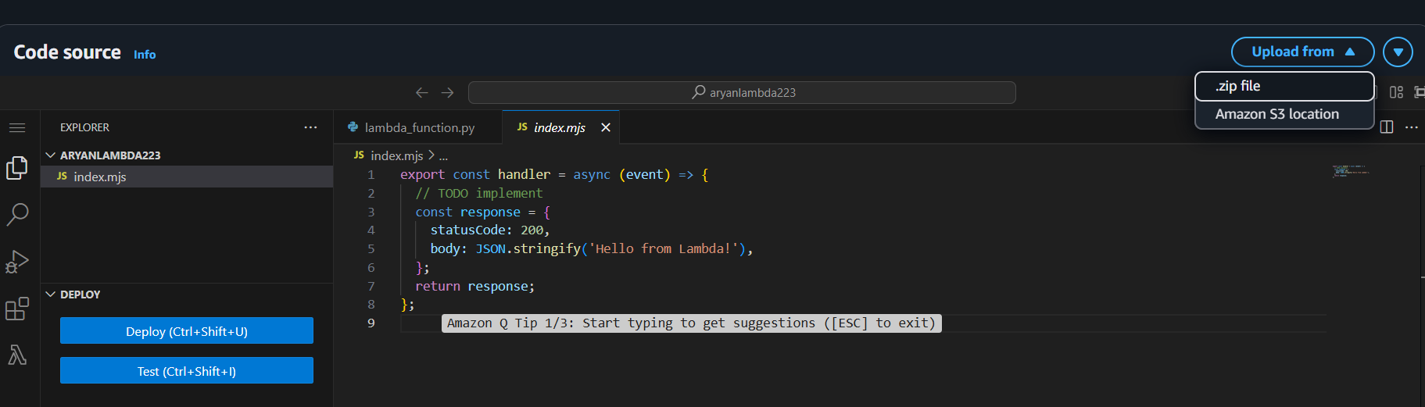
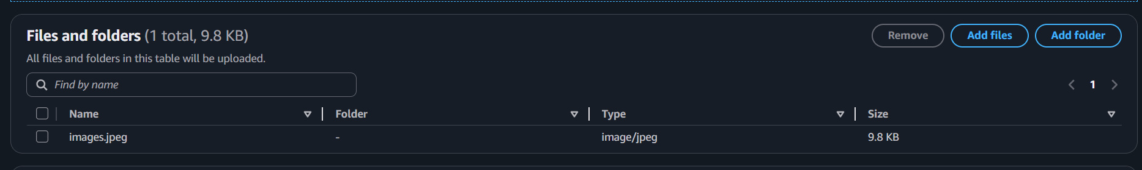
Step 18- Now add zip to lambda function.
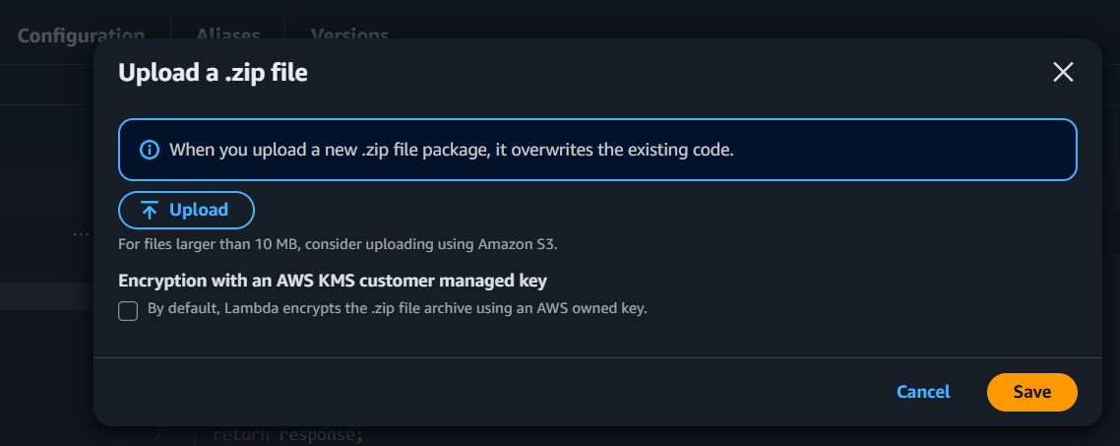
Step 19- upload the zip file.

Step 20- Upload the file and save.

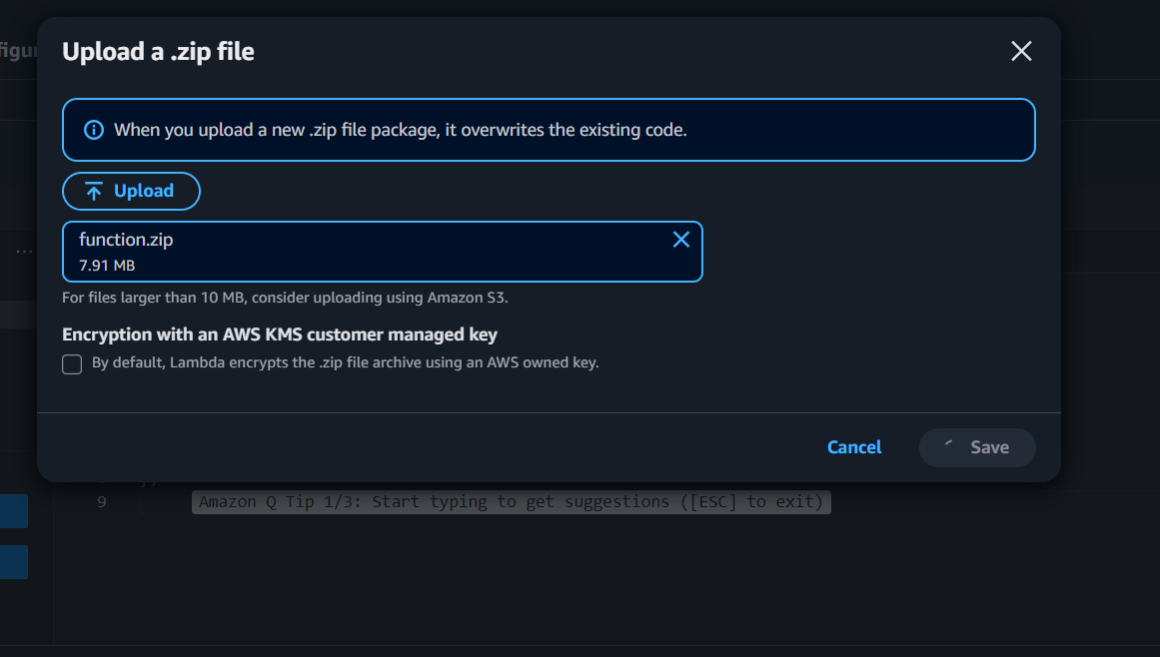
Step 21- Now go to configuration.
Step 22- select edit.
Step 23- Now go to environmental variable.
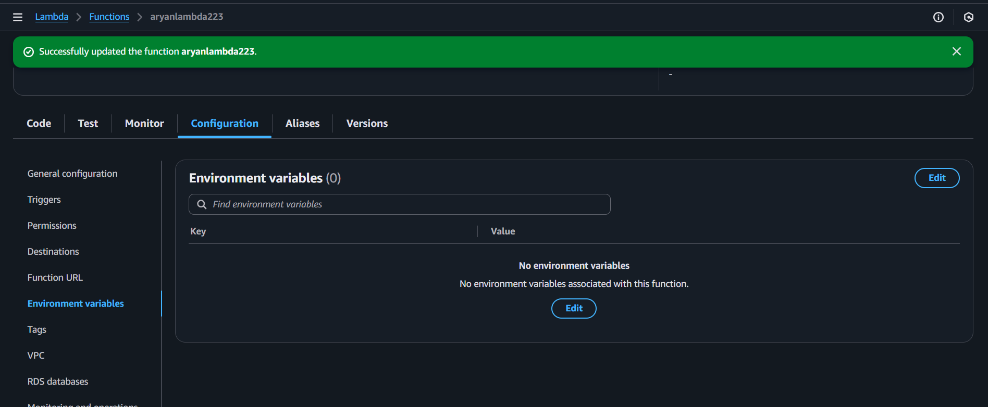
Step 24- select edit.

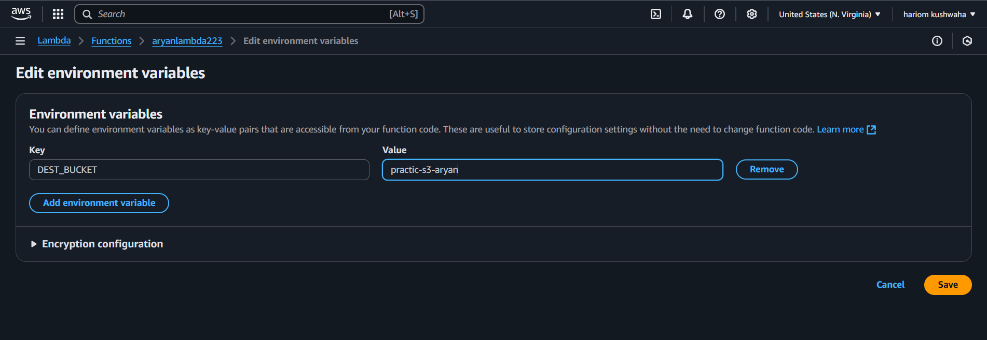
Step 25- Now selects the destination bucket.

Step 26- Save it.
Step 27- Now goes to the test.
Step 28- Select template.
Step 29- select s3 on the search bar.
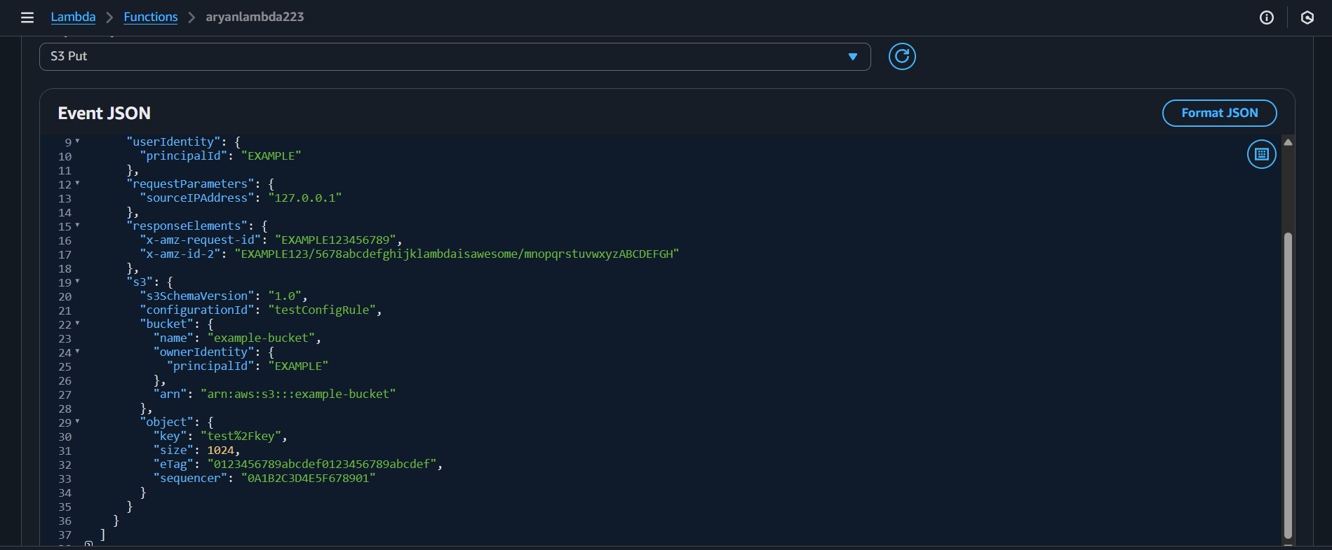
Step 30- This code is modified with your existing s3 bucket and the key name is your image name in the s3 bucket.
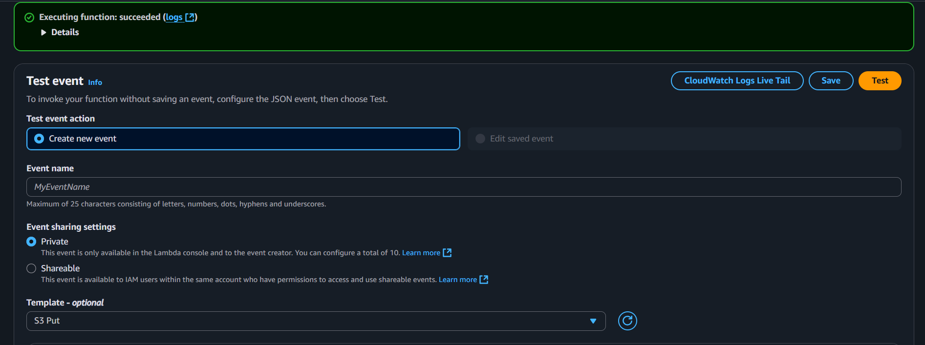
Step 31- Now go to test this code.

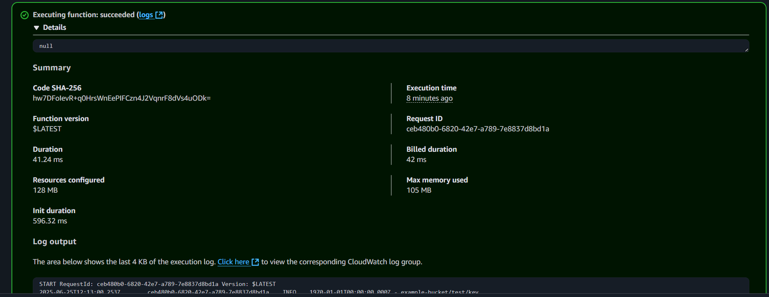
Step 32- The code test is successfully run.
- Step 33- Now we can see s3 buckets with the actual size of the image.

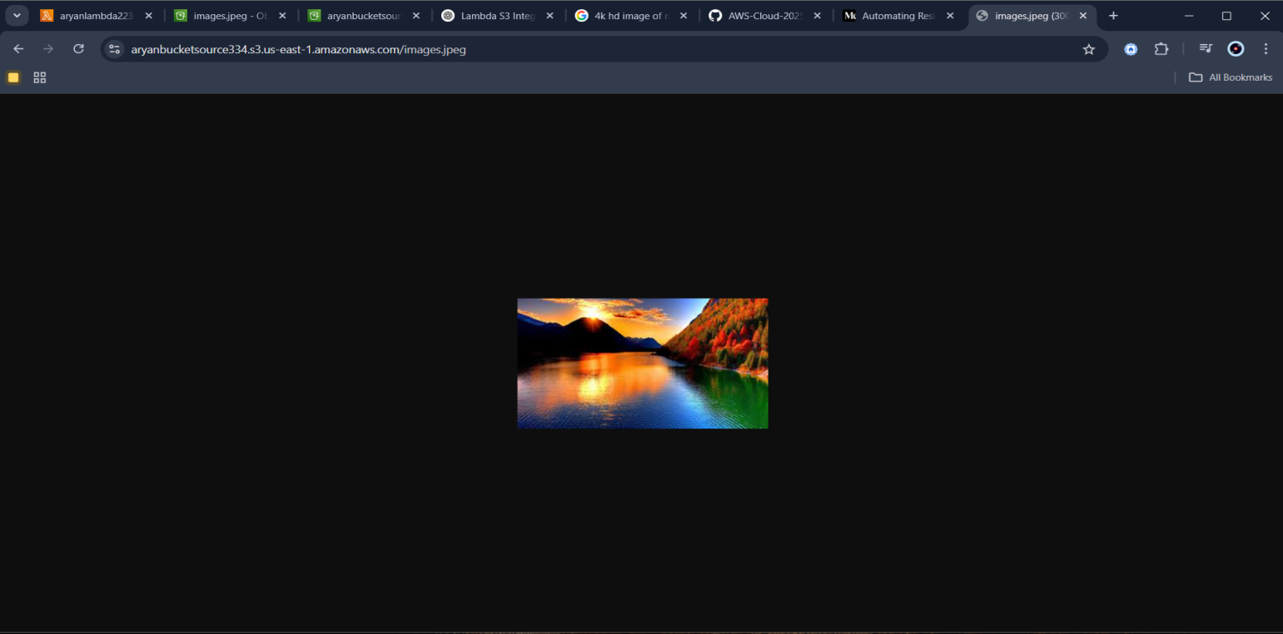
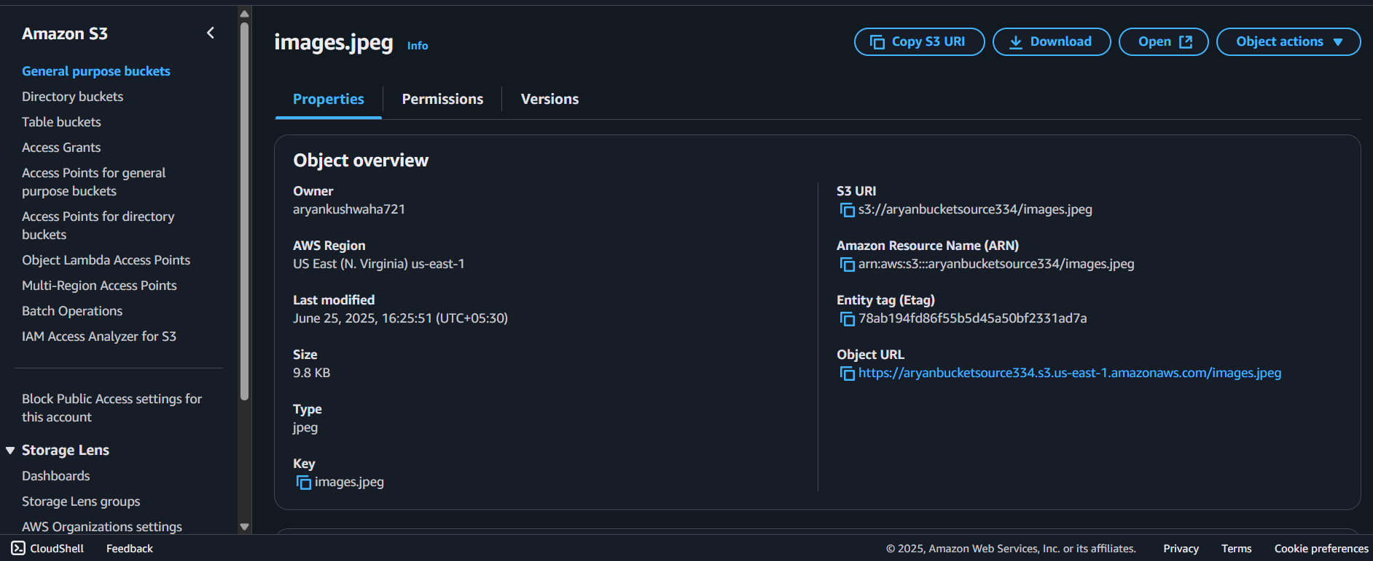
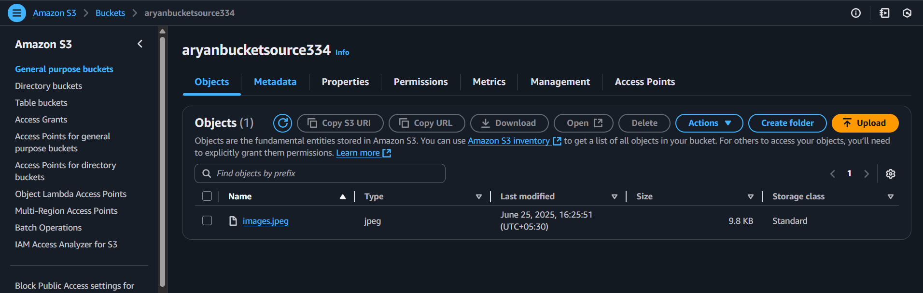
Conclusion
Automating image processing using AWS Lambda in conjunction with Amazon S3 offers a scalable and efficient approach to managing image-related tasks. This method facilitates real-time processing of images upon upload and enables resizing or transformation to meet specific application requirements. The following step-by-step guide outlines the process of developing customized Lambda functions designed to address various image processing needs. By experimenting with different configurations and functionalities, users can optimize and refine their automated image processing workflows within the AWS cloud environment.

